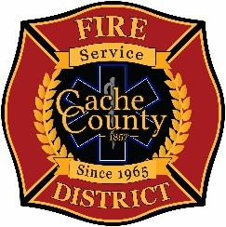
CACHE COUNTY FIRE DISTRICT
BOARD OF TRUSTEES
Kathryn Beus – Board Chair George Daines – Trustee
David Erickson – Trustee Steve Miller – Trustee
Lyndsay Peterson – Trustee Aaron Rudie – Trustee
Larry Jacobsen - Trustee

BOARD OF TRUSTEES MEETING
May 12, 2026
2:00pm

AGENDA
The Cache County Fire District Board will meet Tuesday, May 12, 2026, commencing at 2:00 p.m. in the Cache County Historic Courthouse, Council Conference Room, 199 North Main Logan, Utah 84321.
- CALL TO ORDER:
- ITEMS OF BUSINESS
  - Approval of Agenda – May 12, 2006
  - Approval of Minutes – April 27, 2026
- ITEMS OF DISSCUSION
  - Report/Discussion on Mayors’ Meeting
  - Discussion and Possible Action – Membership in the Utah Association of Special Districts
- NEXT MEETING
June 25, 2026 – 2:00pm
- ADJOURN

In compliance with the Americans with Disabilities Act, individuals needing special accommodations (including auxiliary communicative aids and services) during this meeting should notify Janeen Allen, at 755-1850 at least three working days prior to the meeting.

